**User Manual Document**

**Module- KIIT Polytechnic**

**September 2022, Version-1.0**



**Sustainable Outreach and Universal Leadership Limited**

**Sign off Date     Signature Client Signature Consulting**

Landing Page for ICICI Online Payment.

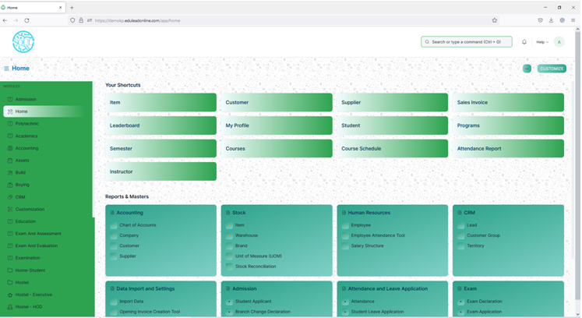

In search bar search for **ICICI Online Payment.**

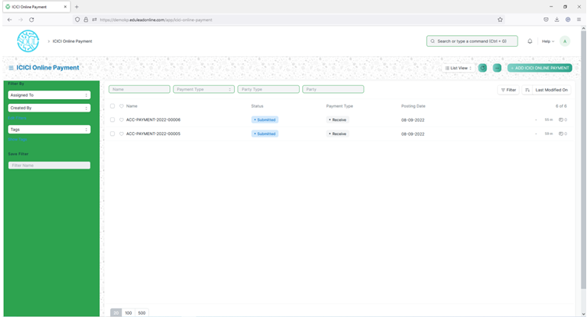

Click on **ADD** **ICICI Online Payment.**

On load of page one disclaimer will be shown. To close it ,clicks on cross mark.

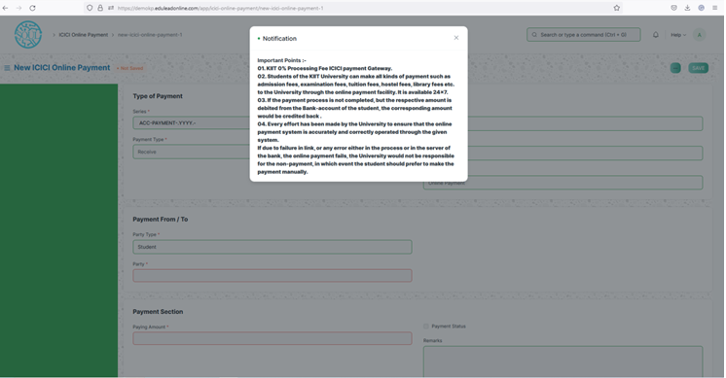

Select the Party from the dropdown list.

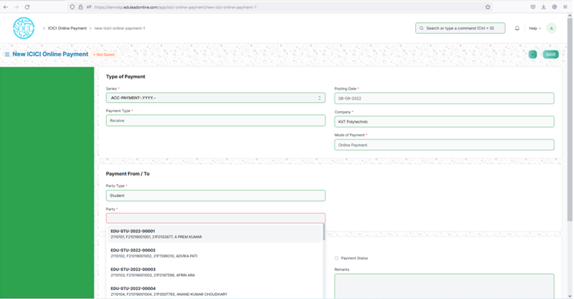

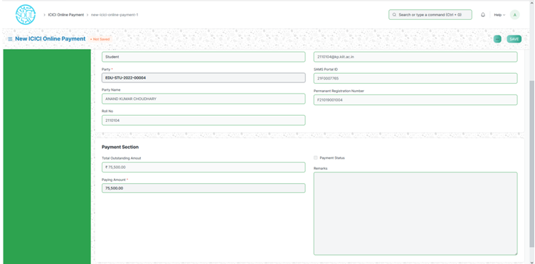

It will show the details of the student along with his/her Total Outstanding amount and paying amount.

Paying amount is editable. Once saved it cannot be modified.

Then Online Payment button will be visible for the processing .Click on Online Payment, it will redirect to ICICI commerce site.

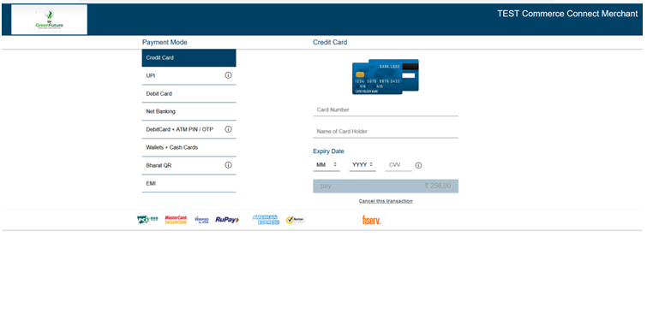

Enter the card details. And click on Pay button.

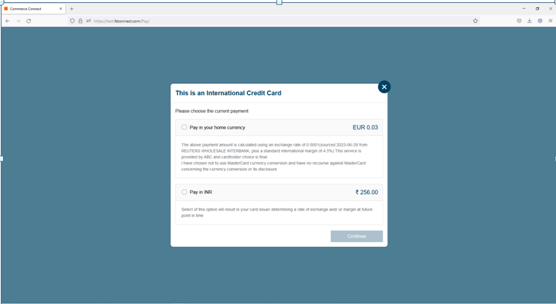

Check the radio button Pay in INR and Continue.

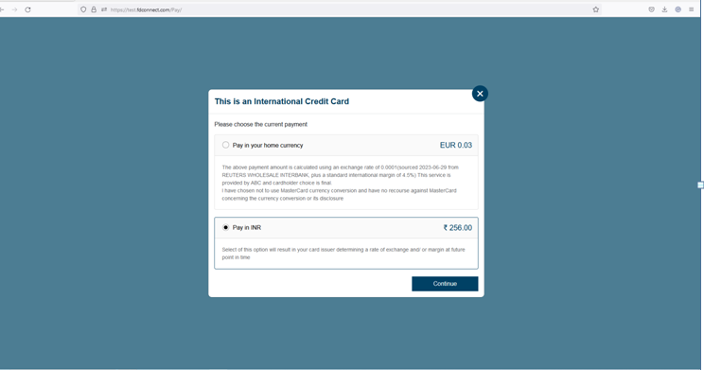

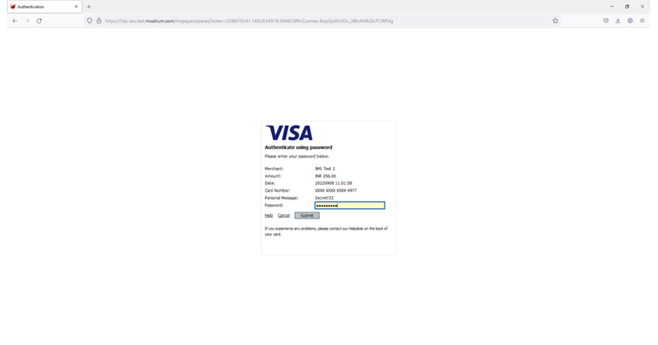

Enter the 3D security pin and click on Submit.

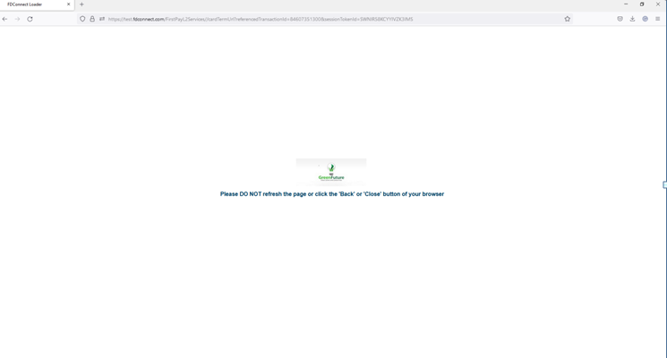

After processing, the transaction details will be fetched from the server as shown in below.

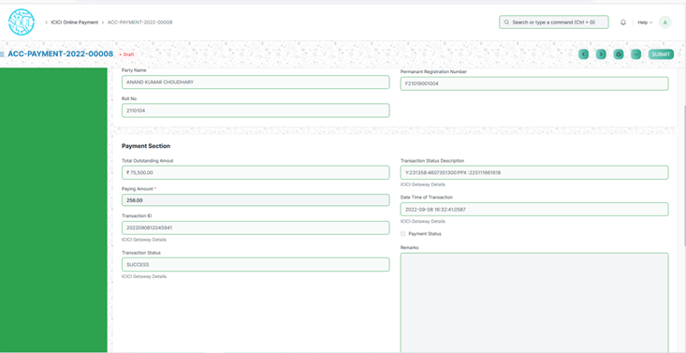

Then click on Submit for confirmation.

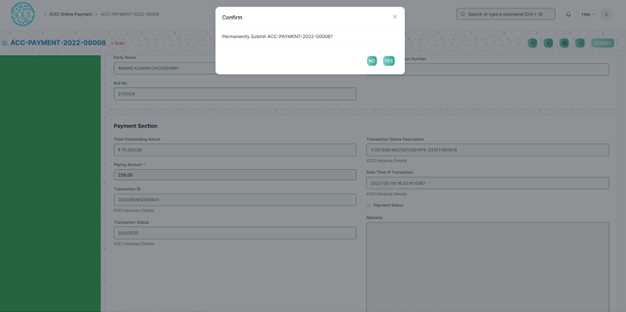

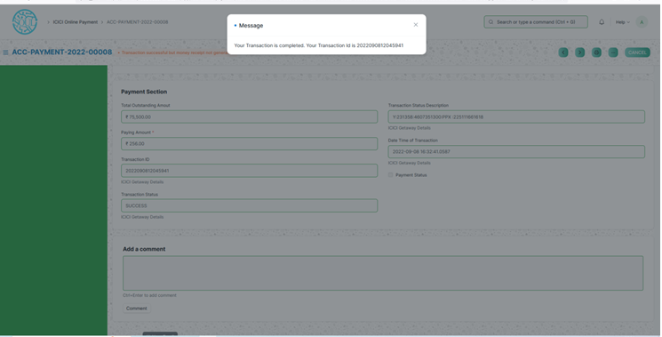

After confirmation a pop up message will be shown mentioning the transaction Id.